Group Members (Group 9)

1. Brendan Rizzo
   1. Brought out some good points to grasp the question and our answer.
2. Richard Huang
   1. Listed many equations and theories(?) that maybe useful to solve the question since he already took MTH 314 and helped me construct the answer.
3. Jiashang Cao
   1. Had hard time trying to understand the question, but ended up understanding and helped us to get the answer.
4. **Eden Seo**
   1. Organized what Brendan and Richard provided and came up with an explanation.

Problem 1.2

* 1. 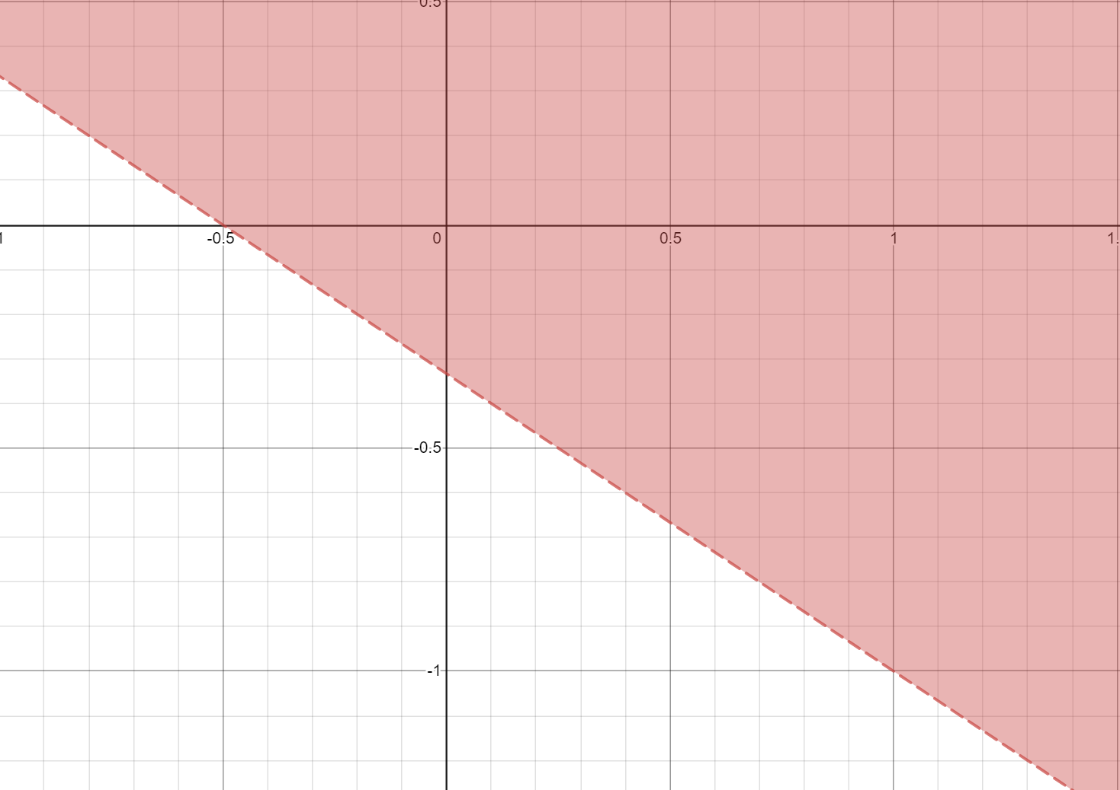
  2. 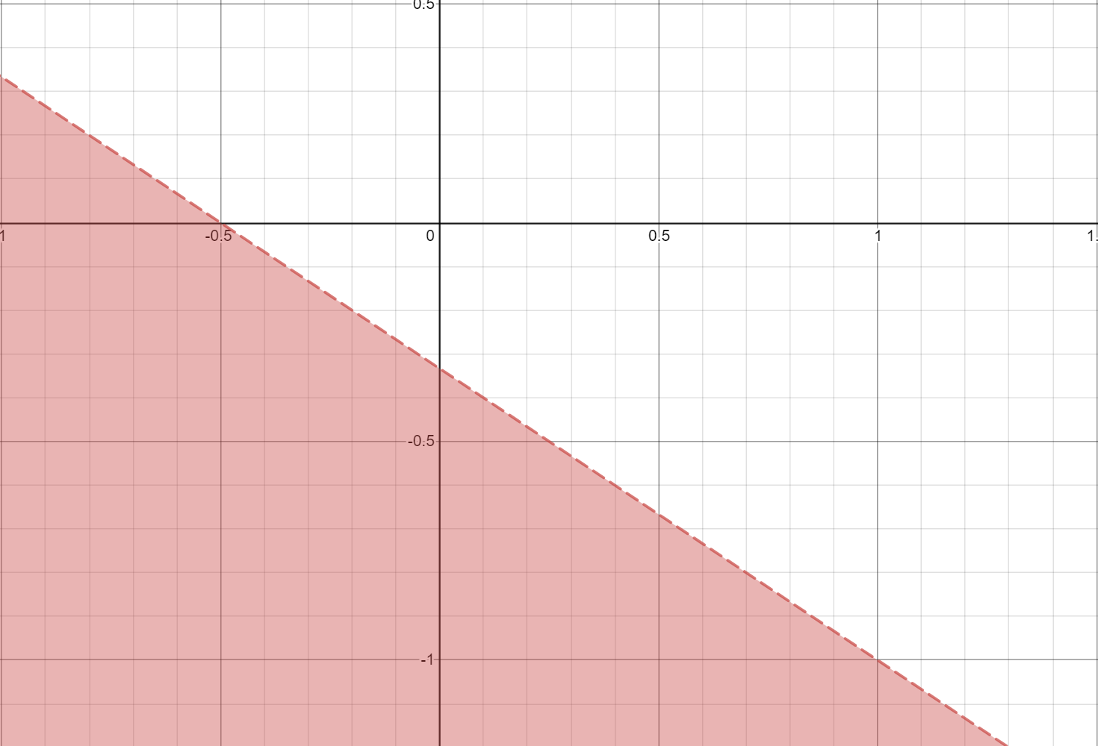

Problem 1.4

1. 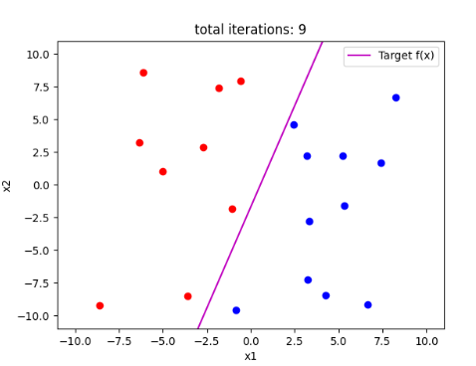
2. 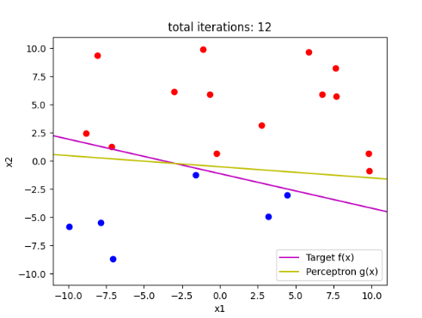Perceptron g(x) is close enough to the target f(x)
3. 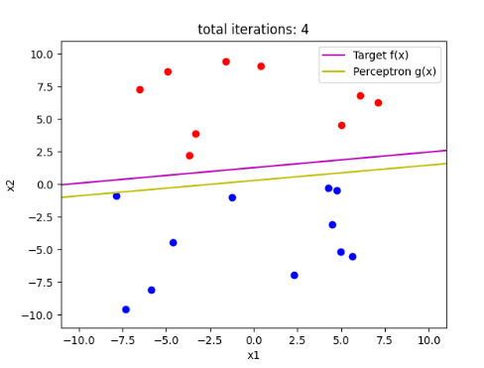
4. 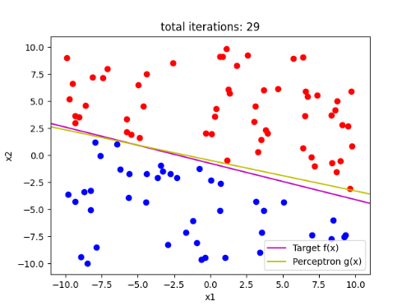
5. 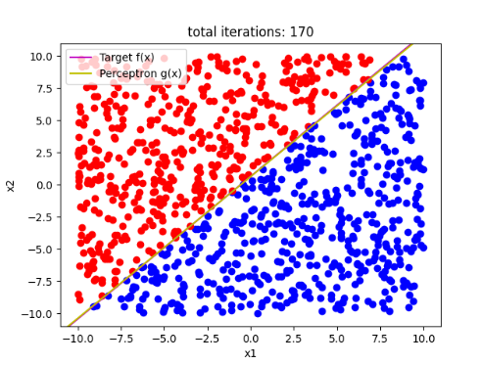

Question 3

1. The Perceptron code is inside the .py file that I turned it in via mimir. It is part of the code that I used to solve Problem 1.4